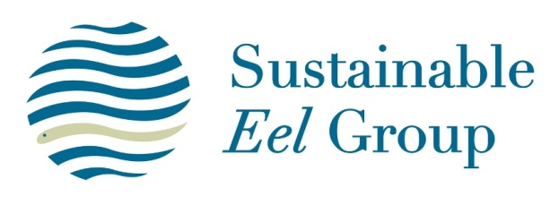
Comments on the SEG Standard

Purpose of this document
This document is to enable stakeholders to provide comments and feedback on the SEG Standard – its content, application and supporting procedures.

If you have any comments on the Standard or its supporting procedures, please complete this form and send it to standard@sustainableeelgroup.org

Document Name | Section or Page | Comments
Please add extra rows if you need to

Sustainable Eel Group
Version 1.1 22/2/17

